My Amazon Book
Of Shadows

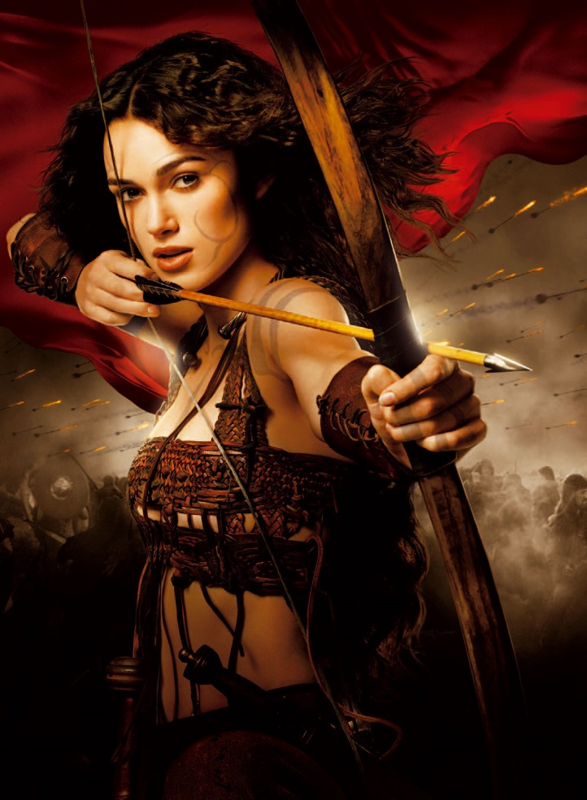

Table of Contents

The Amazon Rede
The Amazon Chant
The Amazon Year is a Changing Womyn

Spring
Ostara
Maiden
Initiate
East
Air
Weaver
Plantingmas
Wand
Word Smith & Lyricist
Garden Keeper

Summer
Litha
Mistress
Guardian Priestess
South
Fire
Archer
Harvestmas
Staff
Hunter & Harvester
Creature Keeper

Autumn
Mabon
Moher
Ritual Priestess
West
Water
Teacher
Hallowmas
Chalice
Artist & Artisan
Hearth Keeper

Winter
Yule
Matriarch
High Priestess
North
Earth
Drummer
Candlemas
Cauldron
Healer & Midwife
Dream Keeper

My Astrological Chart
Spells

The Amazon’s Rede
by Laurie J. Kendall
2015

Abide within the law you must,
Enter the circle in love and trust.

No challenge be made with word or with blade,
And beware of secrets, for from trouble they’re made.

Practice your rituals naked or not,
Braiding your cords with nine simple knots.

From within your circle a priestess you call,
For her service is recognized by one and by all.

Observe no distinctions or degrees of three,
Though knowledge is earned, it is shared willingly.

Tread the circle thrice around,
Weaving and casting Her energy abounds.

Deosil as the sun doth go,
Charging up the energy flow.

Widdershins as the water drains,
Pulling down the energy wanes.

When Her moon is dark and new,
Begin your spells and potions and brews.

When Her moon is full and bright,
Give thanks for Her gifts and all your delights.

To cast a spell in its time,
Speak the words in a rhyme.

Mind the law of three times three,
For as you will it, so shall be.

Live your desire and let you live,
Freely take and freely give.
On Hallowmas we look for a sign,
And call the priestesses in our line.
For their magickal skill and willingness to serve,
Our gratitude and honor they deserve.

On Yule when the night is longest,
We honor the Matriarch, the wisest and strongest.
She enters the forth mystery, the cauldron of change,
And in her dreams she creates new life from all that remains.

On Candlemas when the light returns,
She enters the fifth mystery as the Wheel of the Year turns.
When She quickens we see a new way,
and begin our new studies for a Year and a Day.

These Eight words this Rede fulfills,
“If ye harm none, do as you will.”

The Amazon’s Chant

Circle Amazons, as the charge is made,
and witness how our powers are weighed.

Ancestors of the East and West,
come now, your daughters to Bless.

Ancestors of the South and North
Come! Now! We call ye forth!

Horned Huntress of the night
Give my vision magic flight!

Artemis,
Queen of Shadow, Queen of Light,
work my will by magic rite!

On darksome night and shining moon
We hearken to the Amazon's rune.

Cauldron, Cup, Candle, and Cord,
In thee my powers are stored!

Wand, Staff, Athame, and Bow
In thee my powers now flow!

By all the powers of land and sea
Be an ally unto me.

By all the powers of Moon and Sun
As I do will, SO SHALL IT BE DONE!

Adapted from “The Witch’s Chant,” by Lady Sheba, 1974.

Bright of sight and soft of touch,
Speak little and listen much.

Be mindful of men, for from Goddess they blaze.
But teach them not, for they know not your ways.

Circle with men and your Queen will fall.
She is enough, for She gave birth to us all.

Standing alone, no consort She needs.
She is complete, both stamen and seed.

Circle with sisters and soon you will see,
How safe and happy, and loved you will be.

On Ostara when the days grow long,
Through the first mystery of blood so strong,
We honor the Maiden by sounding Her horn.
In love and joy, and song She is born.

On Plantingmas when She opens and flowers,
Her moon bloods flow in strength and power.
When the second mystery She does know,
like the Earth we womyn blossom and grow.

On Litha when the day is longest,
She comes to us when Her passion is strongest.
We honor the Mistress when the sun is hot,
And opening to Her, love we are taught.

On Harvestmas when Her belly is ripe,
We honor Her with the playing of pipes.
Giving thanks for Her gifts we eat our fill,
For in love and joy Her crops we did till.

On Mabon when the night grows long,
We honor the Mother and Her labor in song.
When the third mystery comes and Her babes are born,
We feed at Her breast into the wee hours of morn.

The Amazon Year Is a Changing Womyn
By Laurie J. Kendall
2012

At Ostara, the Spring Equinox, I enter the first mystery when I give birth to my child-self. I am the Maiden, the Weaver who begins the tapestry of life. Threads of blue are my waters, the rivers and streams, and oceans that course through my body. Red threads are my bloods, the magma & lava that pulse through my veins. Green threads are the grasses & leaves that cover my head. Threads with the colors of sand, clay, and rich fertile soil are my skin, and cover my bones like a supple blanket. I grow like the morning sun rising in the East, and my dance of life is glorious, yet gloriously changing I am.

At Plantingmas I grow quickly, and eagerly explore myself and the universe around me. In this season I become the Initiate, the student, and the Air of inspiration expands my mind and intellect. I hold the pen of the Writer/Scholar, and learn to wield the power of words. When my pen transforms into the Wand, my magic flows through it to bring forth the flowers of Spring. Through me, all things are connected in the web of life. My dance of connection is sensual, yet sensually changing I am.

At Litha, the Summer Solstice, long after I have entered the second blood mystery, I enter the mysteries of the Mistress. On the longest day of the year the Fire of the South rises up in my loins and my passions and appetite become fierce. My hunger drives me to become the Gardener/Drummer, bringing forth the fruit of the Earth with the passionate rhythms that pulse through my body. Now I teach myself the arts of love making. My dance of love is sexual, yet sexually changing I am.

At Harvestmas I become the Guardian Priestess, keeping watch over my fields and herds. Yet in the heat of my passion I transform into the ravenous Hunter/Harvester who takes up the bow and the scythe. With my Staff I walk the fields digging roots, and in the orchards I knock fruits & nuts from the trees. My dance of desire is passionate, yet passionately changing I am.

Spring

At Mabon, when day and night are balanced at the Autumn Equinox and my belly is full from summer passions, I enter the third mystery when I become the Mother. I balance the death of the harvest with the life force of my womb, and through blood I give birth to my children. They are wondrous, and their bodies are rich with my colors. For them I become the Hearth Keeper who feeds them and keeps the fire burning at home. I become the Artisan/Builder who inspires them to craft & create their own realities, as I have created mine. My dance of birth is sustaining, yet sustaining change I am.

At Hallowmas I become the Ritual Priestess, creating sanctuary and safety for my children and tribe. With the setting of the sun in the West, I become the twilight, the walker between worlds. I am the veil between light and dark, the stream that flows between life and death. Into my Chalice I pour the Water of the past, present, and future. There, they exist simultaneously, and when I gaze into the cup I see all of my reflections; who I have been, who I am, and who I will be again. I dance the spiral dance, spiraling into the ever changing Universe I am.

At Yule, the longest night of the year, I enter the fourth mystery. When my moon bloods no longer flow, I become the Matriarch of the spiraling Universe. At the celebration of Yule I make love to myself in my deep dreamtime, and I conceive myself anew in the womb of my imagination. I am the Artist who sculpts myself into being, the Goddess of a thousand faces. My dance of creation is forever, yet forever changing I am.

At Candlemas I breathe in and breathe out, and enter the fifth mystery as the flicker in my womb dances like a candle in the night. When the cold North winds blow I feel myself quicken within my womb, the Cauldron of transformation from life to death to life. Deep in the Earth, I transforms into the old Healer/Midwife. There, I wait for the moment when I will deliver myself into the new life of spring. I am the High Priestess of life and death, and life again, and my dance is eternal, yet eternally changing I am.

Ostara

Maiden

Initiate

East

Air

Weaver

Plantingmas

Wand

Word Smith & Lyricist

Garden Keeper

Summer

Litha

Mistress

Guardian Priestess

South

Fire

Archer

Harvestmas

Staff

Hunter & Harvester

Creature Keeper

Autumn

Mabon

Mother

Ritual Priestess

West

Water

Teacher

Hallowmas

Chalice

Artist & Artisan

Hearth Keeper

Winter

Yule

Matriarch

High Priestess

North

Earth

Drummer

Candlemas

Cauldron

Healer & Midwife

Dream Keeper

My Astrological Chart

Sun:

Moon:

Rising:

North Node:
Mercury:

Venus:

Mars:

Jupiter:

Saturn:

Uranus:

Neptune:

Pluto:

4th House – How You Relate to Home, Hearth, and Family

5th House –Your Self-Esteem and Where You Find Pleasure

6th House – How You Respond to Obligations and Responsibilities

7th House – How Your Respond to Romantic Relationships

8th House – Indicates Your Life Challenges and Need for Growth

9th House – Indicates Your Religious or Philosophical Systems

1st House – Primary Personality – Reason You Are Here

2nd House – How You Attend to Your Physical and Financial Needs

3rd House – Relates to Your Intellect and How Your Process

10th House –Indicates Your Professional or Career Path

11th House – Indicates Your Creativity and Group Interactions

12th House – Indicates Your Greatest Fears and Anxieties

Spells

